XBox USB Simulator

Table Of Contents
1 Introduction 1
1.1 Sample Transaction 1
1.2 Type of Tests 2
2 Functional Requirements 2
3 Simulator Requirements 2
4 Ethernet Communication 2
4.1 TCP/UDP Ports 3
4.2 Packet Definition 3
4.3 Command List 3
5 Device Enumeration Sample 4
5.1 Connect A Device 4
5.2 Get Device Descriptor 4
5.3 Set Address 5
5.4 Get Configuration Description 6
5.5 Set Configuration 8
5.6 Get XID Descriptor 9
6 Future Enhancements 10
7 Appendices 10
7.1 References 10
8 Glossary 10

Version 1.1
Last Edited: 6/1/2000

Introduction
This document describes the functionality required for testing the XBox USB software and hardware. A custom USB device (called the USB Simulator in this document) will be used to simulate multiple XBox peripherals. These “virtual devices” will be programmable and controlled through software on another computer, or the same XBox, (called the Controller in this document).

The Simulator will act like a USB hub and must support multiple virtual devices, each with different capabilities. These virtual devices will support XID and bulk transfers. The actual devices will be operated in real-time via the controller through an Ethernet (TCP/IP communication) connection. So responses to USB commands from the Host will always come from the controller.

Our current XBox hardware configuration will allow up to 5 simulators will be attached at the same time.

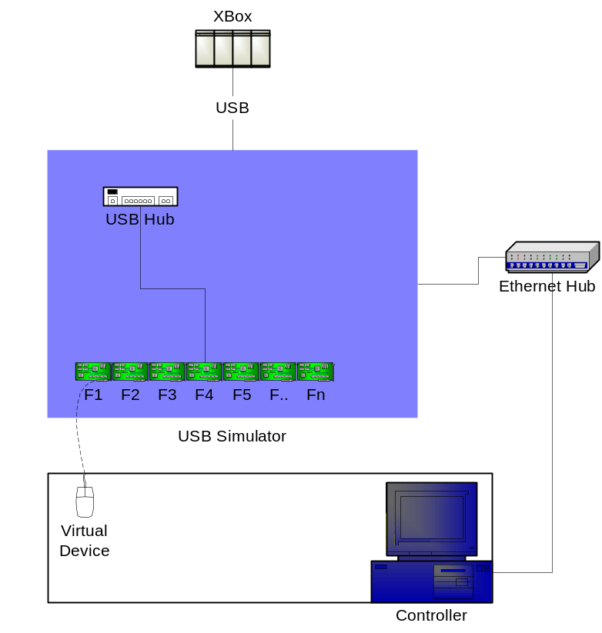

Sample Transaction
From | To | Protocol | Description
XBox | Simulator | USB | IN packet
Simulator | Controller | TCP/IP | IN packet
Controller | Simulator | TCP/IP | DATA1 + 8bytes data …
Simulator | XBox | USB | DATA1 + 8bytes data + CRC …

Type of Tests
The following is a short list of the types of tests that will be used to validate the XBox USB hardware and software.
- Device enumeration stress
- Data stress
- Testing the limits on the total number of connected devices
- XID packet tests (e.g. boundary cases on the different fields)
- MU testing (simulate memory cards on the controller)
- Isocronous tests (such as voice and audio)
- Invalid data (e.g. sending corrupted XID packets or bad responses during device enumeration)

Functional Requirements
This is the list of general functional requirements of the USB Simulator.
- Act like a hub
- Support at least seven devices
- Support for bulk transfer
- Support for Isocronous transfers
- Send all USB communication from the host to the controller
- Send USB responses from the controller back to the host

Simulator Requirements
Here is a list of hardware and software requirements on the simulator.
- USB connection
- Dongle to support XBox’s USB connector
- USB Cable must be able to extend up to 8 feet and be robust with respect to noise immunity (braided shields, etc.)
- 100Mbit Ethernet connector
- Jumpers that configure the IP address
- Access to the electrical signals and power
- Breakout functions that allow probing of D+ and D-
- Ability to insert a different power supply
- TCP/UDP Server that listens on ports 200 and 201
- Take care of the USB CRCs and ACK and NAKs at the appropriate times

Ethernet Communication
Communication with the Simulator and Controller will be handled through TCP/IP sockets over the Ethernet connection. The Simulator will act as a “server” and listen on ports 200 and 201. The controller will be the “client” and initiate any connections.

Since the controller will not necessarily know the IP address of all the connected simulators – the controller will send out a broadcast command asking for their IPs. The simulators will then respond with their IP address then the controller will be able to initialize a TCP connection on port 201.

The controller and simulator will be required to send and receive on port 201 without blocking each other. Thus while the controller is sending a USB request, the simulator can be receiving that request and sending a response from the previous request.

If the simulator does not get a response from the controller quickly enough what happens, then it should respond with a NAK.

TCP/UDP Ports
Port | Description
200 UDP | Broadcast
201 TCP | IO

Packet Definition
Packet Format
Size | Description
8bits | Function #
8bits | Command
8bits | Subcommand
8bits | Data Size (number of bytes)
 | Data

Command List
Direction From | Cmd | Sub Cmd | Description | Data Example
Simulator | 1 | 0 | Data contains USB request | Setup packet:  0xB4 0x00 0x00
Controller | 1 | 0 | Data contains USB response | Data0 response:  0xC3 0x01 0x02 … 0x08
Controller | 2 | 0 | IP Query (broadcast) | None
Simulator | 2 | 0 | IP Query Response (broadcast) | 0x01 0x02 0x03 0x04
Controller | 3 | 1 | Connect a new device | None
Controller | 3 | 2 | Disconnect an existing device | None
Controller | 4 | 1 | Request status of devices | None
Simulator | 4 | 1 | Bit mask of connected devices | 0010110
Controller | 4 | 2 | Request MAC Address | None
Simulator | 4 | 2 | MAC Address response | 0x27 0xA5 … 0x43
Controller | 5 | 1 | Send an ACK at the next appropriate time | None
Controller | 5 | 2 | Send a NAK at the next appropriate time | None
Controller | 5 | 3 | Do not send an ACK or NAK | None
Simulator | 6 | 1 | Data contains sent ACK or NAK | …
Simulator | 6 | 2 | Data contains USB response that controller does know about | Default response for XID packet:  0xC3 0x01 0x02 … 0x08

Device Enumeration Sample

Connect A Device
TCP: Controller sends a “connect new device” command to simulator for port 3
Func # | Cmd | Sub Cmd | Data Size | Data
0x03 | 0x03 | 0x01 | 0x00

Get Device Descriptor
USB: Host sends setup packet
PID | Data
0xB4 | 0x00 0x00

USB: Host sends data0 packet
PID | Data
0xC3 | 0x80 0x06 0x00 0x01 0x00 0x00 0xFF 0x00

USB: Simulator automatically responds with ACK
PID | Data
0x4B

TCP: Simulator forwards setup to controller
Func # | Cmd | Sub Cmd | Data Size | Data
0x03 | 0x01 | 0x00 | 0x03 | 0xB4 0x00 0x00
Data contains: setup PID, address, and endpoint.

TCP: Simulator forwards data0 to controller
Func # | Cmd | Sub Cmd | Data Size | Data
0x03 | 0x01 | 0x00 | 0x09 | 0xC3 0x80 0x06 0x00 0x01 0x00 0x00 0xFF 0x00

TCP: Simulator notifies controller of the ACK
Func # | Cmd | Sub Cmd | Data Size | Data
0x03 | 0x06 | 0x01 | 0x01 | 0x4B

USB: Host sends IN packet
PID | Data
0x96 | 0x00 0x00

TCP: Simulator forwards IN packet to controller
Func # | Cmd | Sub Cmd | Data Size | Data
0x03 | 0x01 | 0x00 | 0x03 | 0x96 0x00 0x00

TCP: Controller sends data1 response
Func # | Cmd | Sub Cmd | Data Size | Data
0x03 | 0x01 | 0x00 | 0x09 | 0xD2 0x12 0x01 0x10 0x01 0x00 0x00 0x00 0x08

USB: Simulator forwards response to host
PID | Data
0xD2 | 0x12 0x01 0x10 0x01 0x00 0x00 0x00 0x08

USB: Host responds with ACK
PID | Data
0x4B

TCP: Simulator forwards the ACK
Func # | Cmd | Sub Cmd | Data Size | Data
0x03 | 0x06 | 0x01 | 0x01 | 0x4B

Set Address
USB: Host sends setup packet
PID | Data
0xB4 | 0x00 0x00

USB: Host sends data0 packet
PID | Data
0xC3 | 0x00 0x05 0x02 0x00 0x00 0x00 0x00 0x00

USB: Simulator automatically responds with ACK
PID | Data
0x4B

TCP: Simulator forwards setup to controller
Func # | Cmd | Sub Cmd | Data Size | Data
0x03 | 0x01 | 0x00 | 0x03 | 0xB4 0x00 0x00

TCP: Simulator forwards data0 to controller
Func # | Cmd | Sub Cmd | Data Size | Data
0x03 | 0x01 | 0x00 | 0x09 | 0xC3 0x00 0x05 0x02 0x00 0x00 0x00 0x00 0x00

TCP: Simulator notifies controller of the ACK
Func # | Cmd | Sub Cmd | Data Size | Data
0x03 | 0x06 | 0x01 | 0x01 | 0x4B

USB: Host sends IN packet
PID | Data
0x96 | 0x00 0x00

TCP: Simulator forwards IN packet to controller
Func # | Cmd | Sub Cmd | Data Size | Data
0x03 | 0x01 | 0x00 | 0x03 | 0x96 0x00 0x00

TCP: Controller sends data1 response
Func # | Cmd | Sub Cmd | Data Size | Data
0x03 | 0x01 | 0x00 | 0x01 | 0xD2

USB: Simulator forwards response to host
PID | Data
0xD2

USB: Host responds with ACK
PID | Data
0x4B

TCP: Simulator forwards the ACK
Func # | Cmd | Sub Cmd | Data Size | Data
0x03 | 0x06 | 0x01 | 0x01 | 0x4B

Get Configuration Description
USB: Host sends setup packet
PID | Data
0xB4 | 0x02 0x00

USB: Host sends data0 packet
PID | Data
0xC3 | 0x80 0x06 0x00 0x02 0x00 0x00 0x50 0x00

USB: Simulator automatically responds with ACK
PID | Data
0x4B

TCP: Simulator forwards setup to controller
Func # | Cmd | Sub Cmd | Data Size | Data
0x03 | 0x01 | 0x00 | 0x03 | 0xB4 0x02 0x00

TCP: Simulator forwards data0 to controller
Func # | Cmd | Sub Cmd | Data Size | Data
0x03 | 0x01 | 0x00 | 0x09 | 0xC3 0x80 0x06 0x00 0x02 0x00 0x00 0x50 0x00

TCP: Simulator notifies controller of the ACK
Func # | Cmd | Sub Cmd | Data Size | Data
0x03 | 0x06 | 0x01 | 0x01 | 0x4B

USB: Host sends IN packet
PID | Data
0x96 | 0x02 0x00

TCP: Simulator forwards IN packet to controller
Func # | Cmd | Sub Cmd | Data Size | Data
0x03 | 0x01 | 0x00 | 0x03 | 0x96 0x02 0x00

TCP: Controller sends data1 response
Func # | Cmd | Sub Cmd | Data Size | Data
0x03 | 0x01 | 0x00 | 0x09 | 0xD2 0x09 0x02 0x29 0x00 0x01 0x01 0x04 0x80

USB: Simulator forwards response to host
PID | Data
0xD2 | 0x09 0x02 0x29 0x00 0x01 0x01 0x04 0x80

USB: Host responds with ACK
PID | Data
0x4B

TCP: Simulator forwards the ACK
Func # | Cmd | Sub Cmd | Data Size | Data
0x03 | 0x06 | 0x01 | 0x01 | 0x4B

USB: Host sends IN packet
PID | Data
0x96 | 0x02 0x00

TCP: Simulator forwards IN packet to controller
Func # | Cmd | Sub Cmd | Data Size | Data
0x03 | 0x01 | 0x00 | 0x03 | 0x96 0x02 0x00

TCP: Controller sends data0 response
Func # | Cmd | Sub Cmd | Data Size | Data
0x03 | 0x01 | 0x00 | 0x09 | 0xC3 0x32 0x09 0x04 0x00 0x00 0x02 0x03 0x00

USB: Simulator forwards response to host
PID | Data
0xD2 | 0x32 0x09 0x04 0x00 0x00 0x02 0x03 0x00

USB: Host responds with ACK
PID | Data
0x4B

TCP: Simulator forwards the ACK
Func # | Cmd | Sub Cmd | Data Size | Data
0x03 | 0x06 | 0x01 | 0x01 | 0x4B

…

Set Configuration
USB: Host sends setup packet
PID | Data
0xB4 | 0x02 0x00

USB: Host sends data0 packet
PID | Data
0xC3 | 0x00 0x09 0x01 0x00 0x00 0x00 0x00 0x00

USB: Simulator automatically responds with ACK
PID | Data
0x4B

TCP: Simulator forwards setup to controller
Func # | Cmd | Sub Cmd | Data Size | Data
0x03 | 0x01 | 0x00 | 0x03 | 0xB4 0x02 0x00

TCP: Simulator forwards data0 to controller
Func # | Cmd | Sub Cmd | Data Size | Data
0x03 | 0x01 | 0x00 | 0x09 | 0xC3 0x00 0x09 0x01 0x00 0x00 0x00 0x00 0x00

TCP: Simulator notifies controller of the ACK
Func # | Cmd | Sub Cmd | Data Size | Data
0x03 | 0x06 | 0x01 | 0x01 | 0x4B

USB: Host sends IN packet
PID | Data
0x96 | 0x02 0x00

TCP: Simulator forwards IN packet to controller
Func # | Cmd | Sub Cmd | Data Size | Data
0x03 | 0x01 | 0x00 | 0x03 | 0x96 0x02 0x00

TCP: Controller sends data1 response
Func # | Cmd | Sub Cmd | Data Size | Data
0x03 | 0x01 | 0x00 | 0x01 | 0xD2

USB: Simulator forwards response to host
PID | Data
0xD2

USB: Host responds with ACK
PID | Data
0x4B

TCP: Simulator forwards the ACK
Func # | Cmd | Sub Cmd | Data Size | Data
0x03 | 0x06 | 0x01 | 0x01 | 0x4B

Get XID Descriptor
USB: Host sends setup packet
PID | Data
0xB4 | 0x02 0x00

USB: Host sends data0 packet
PID | Data
0xC3 | 0xC1 0x06 0x00 0x41 0x00 0x00 0x08 0x00

USB: Simulator automatically responds with ACK
PID | Data
0x4B

TCP: Simulator forwards setup to controller
Func # | Cmd | Sub Cmd | Data Size | Data
0x03 | 0x01 | 0x00 | 0x03 | 0xB4 0x02 0x00

TCP: Simulator forwards data0 to controller
Func # | Cmd | Sub Cmd | Data Size | Data
0x03 | 0x01 | 0x00 | 0x09 | 0xC3 0xC1 0x06 0x00 0x41 0x00 0x00 0x08 0x00

TCP: Simulator notifies controller of the ACK
Func # | Cmd | Sub Cmd | Data Size | Data
0x03 | 0x06 | 0x01 | 0x01 | 0x4B

USB: Host sends IN packet
PID | Data
0x96 | 0x02 0x00

TCP: Simulator forwards IN packet to controller
Func # | Cmd | Sub Cmd | Data Size | Data
0x03 | 0x01 | 0x00 | 0x03 | 0x96 0x02 0x00

TCP: Controller sends data1 response
Func # | Cmd | Sub Cmd | Data Size | Data
0x03 | 0x01 | 0x00 | 0x09 | 0xD2 0x08 0x41 0x00 0x01 0x01 0x01 0x1A 0x04

USB: Simulator forwards response to host
PID | Data
0xD2 | 0x08 0x41 0x00 0x01 0x01 0x01 0x1A 0x04

USB: Host responds with ACK
PID | Data
0x4B

TCP: Simulator forwards the ACK
Func # | Cmd | Sub Cmd | Data Size | Data
0x03 | 0x06 | 0x01 | 0x01 | 0x4B

Future Enhancements
Support for HID so other teams (NT, etc) could leverage this tool
Macro language so the Simulator will perform operations without interaction with the controller

Appendices

References
USB Specification 2.0 | http://www.usb.org/developers/docs.html
TCP | RFC 793 and 1122
UDP | RFC 768 and 1122
IP | RFC 791 and 1122

Glossary

Controller – An XBox or PC that responds to all USB communication packets forwarded on by the Simulator.
Host – The host is the primary USB controller on the XBox.
IP – Internet Protocol, allows for fragmenting, routing and reassembling data packets. An IP Address is a four-byte value representing a unique destination.
Simulator – The hardware/software solution, which will simulate multiple USB devices.
TCP – Transmission Control Protocol referred to as a “reliable” data transport.
UDP – User Datagram Protocol, which is a connectionless data transport.

